TRUESCALE ADVISORY
The TrueScale Playbook™
Executive Worksheet Package
COMPANION TOOLS FOR EXECUTIVE USE

How to use this package
Use one tool around one priority constraint. Complete the blank worksheet first, then compare the level of specificity with the clearly labeled hypothetical example. Replace every teaching assumption with the organization's own evidence.
The worksheets are educational management tools. Financial examples are hypothetical, and the Executive Self-Assessment is not a statistically validated diagnostic, audit, or prediction of business performance.

EXECUTIVE TOOL
Operational Debt Ledger
Ledger field | Executive entry
Constraint or problem
Observable behavior
Frequency or volume
Affected teams, people, or customers
Evidence source
Evidence status | Verified / Estimated / Unknown
Avoidable expense
Recoverable capacity and intended redeployment
Potential exposure
Overlap assumptions
Shared operating mechanism
Proposed intervention
Accountable executive
Measurement and review date
WORKED HYPOTHETICAL
Completed Hypothetical Ledger
Field | Completed teaching example
Constraint | Customer-support exceptions repeatedly reach managers because the approval rule is unclear.
Behavior and frequency | 2,000 cases per month require 8 avoidable minutes of correction; 12 managers each spend 4 avoidable hours per week on rescue.
Affected groups | Customer-support specialists, managers, new hires, and four at-risk customer accounts.
Evidence status | Illustrative assumptions only; replace with internal workflow, payroll, hiring, and customer evidence.
Avoidable expense | $144,000: 8 preventable departures × $18,000 of nonoverlapping recruiting fees and vacancy coverage.
Recoverable capacity | $381,100: rework $112,000 + management rescue $187,200 + new-hire ramp $57,600 + trainer support $24,300. Intended redeployment: coaching, backlog reduction, and improvement work.
Potential exposure | $200,000 gross customer contribution at risk: 4 customers × $50,000. Not a forecast or savings claim.
Overlap rule | Turnover excludes ramp, trainer, and manager hours counted elsewhere; management rescue excludes trainer time.
Mechanism and intervention | Unclear exception authority. Install approval thresholds, required evidence, and an escalation owner.
Owner and review | Hypothetical COO; review weekly for eight weeks.

EDITABLE PROFILE
Blank Four-Domain Profile
Domain | 1 | 2 | 3 | 4 | 5 | Average
Assess | ○ | ○ | ○ | ○ | ○ | ____ / 5
Stabilize | ○ | ○ | ○ | ○ | ○ | ____ / 5
Scale | ○ | ○ | ○ | ○ | ○ | ____ / 5
Accelerate | ○ | ○ | ○ | ○ | ○ | ____ / 5
Calculate each domain average, then type a filled marker (●) over the matching 1-to-5 position or shade the matching cell. Use the notes area to record the operating evidence behind the pattern.
EXECUTIVE TOOL
Profile Notes
Prompt | Executive entry
Lowest domain and evidence
Largest cross-domain gap
Priority constraint
Owner, objective, and review date

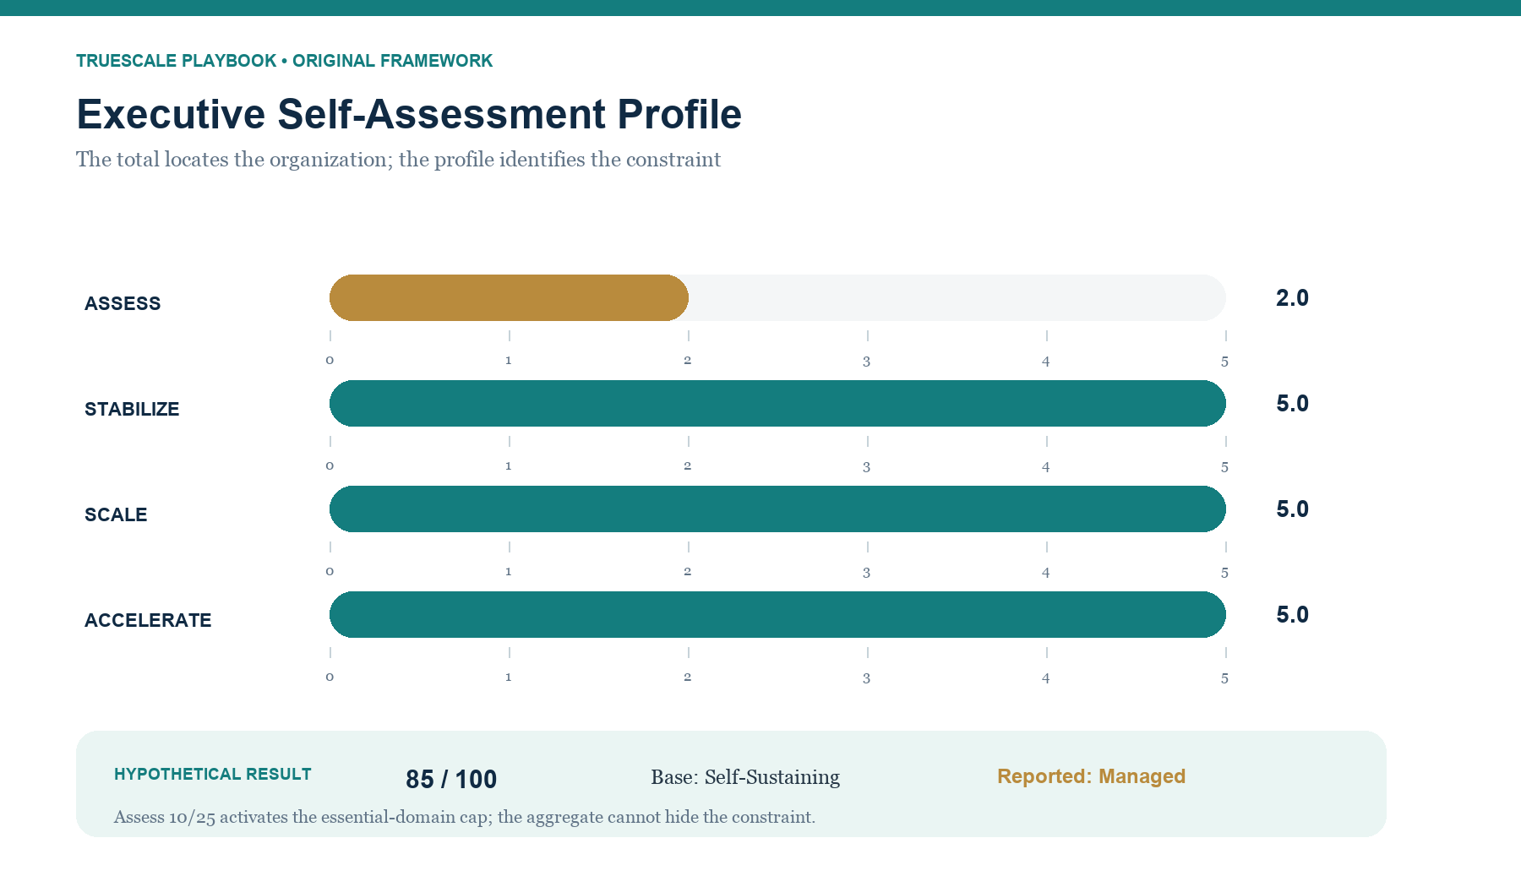
FIGURE 6.1 Illustrative example: completed hypothetical Executive Self-Assessment Profile. Plot your four domain averages before interpreting the aggregate score
EXECUTIVE TOOL
Assessment Profile Worksheet
Result field | Entry
Raw score | ____ / 100
Base stage
Reported stage
Assess subtotal / average | ____ / 25 ____ / 5
Stabilize subtotal / average | ____ / 25 ____ / 5
Scale subtotal / average | ____ / 25 ____ / 5
Accelerate subtotal / average | ____ / 25 ____ / 5
Lowest domain
Critical-control warnings
All scores of 1
Largest executive differences
Priority constraint
Accountable owner
Measurable objective
Review date
ILLUSTRATIVE EXAMPLE
Completed Hypothetical Profile — Illustrative Example
Result field | Completed teaching example
Raw score | 85 / 100
Base stage | Self-Sustaining
Reported stage | Managed
Assess | 10 / 25; average 2.0
Stabilize | 25 / 25; average 5.0
Scale | 25 / 25; average 5.0
Accelerate | 25 / 25; average 5.0
Interpretation | The Assess subtotal activates the essential-domain cap. A strong aggregate cannot qualify the organization as Self-Sustaining while this essential domain remains weak.
Constraint | Decision rights and operating evidence are not reliable enough to support the rest of the system.
Next commitment | Assign an owner, define one decision boundary, measure decision time and escalation volume, and review in 30 days.

EXECUTIVE TOOL
Meeting Contract
Field | Executive entry
Purpose
Decision authority
Participants
Required inputs
Expected outputs
Cadence
Retirement condition
WORKED HYPOTHETICAL
Completed Hypothetical Meeting Contract
Field | Completed teaching example
Purpose | Resolve customer-credit patterns and change the decision rule when evidence requires it.
Decision authority | Managers decide within approved thresholds; the COO decides exceptions outside them.
Participants | COO, customer operations, finance, and the policy owner.
Inputs | Escalation volume, manager-level decision rate, decision time, harmful exceptions.
Outputs | Threshold decisions, assigned policy changes, owners, and dates.
Cadence | Weekly for eight weeks.
Retirement | Retire or reduce cadence when escalation volume is stable inside the agreed threshold for four reviews.

EXECUTIVE TOOL
Decision Brief
Field | Executive entry
Decision
Decider
Required input
Decision criteria
Deadline
Escalation condition
Outcome review
WORKED HYPOTHETICAL
Completed Hypothetical Decision Brief
Field | Completed teaching example
Decision | Approve or decline a customer credit outside the manager threshold.
Decider | COO.
Required input | Customer history, value, service failure evidence, proposed amount, and risk.
Criteria | Customer harm, precedent, contribution, reversibility, and policy intent.
Deadline | One business day.
Escalation | Legal, compliance, or material financial exposure outside the COO's authority.
Outcome review | Review patterns in the weekly operating meeting; reassess thresholds after eight weeks.

EXECUTIVE TOOL
KPI Contract
Field | Executive entry
KPI
Definition and scope
Data source
Owner
Review frequency
Threshold or pattern
Required response
Review date
WORKED HYPOTHETICAL
Completed Hypothetical KPI Contract
Field | Completed teaching example
KPI | Manager-level customer-credit decision rate.
Definition | Eligible credit decisions completed by managers within the approved threshold ÷ all eligible decisions.
Source | Credit-decision log; policy owner verifies scope weekly.
Owner | VP Customer Operations.
Frequency | Weekly for eight weeks.
Threshold | Below 80%, or any harmful exception.
Response | Review classification errors, coaching needs, and threshold design; assign corrective action.
Review date | End of week eight.

EXECUTIVE TOOL
AI Pilot Decision Worksheet
Field | Executive entry
Operating problem
AI use case
Risk class | Assist / Recommend / Act within boundaries / Consequential
Baseline
Expected improvement
Accountable owner
Data and privacy controls
Human review
Error thresholds
Pilot duration
Success criteria
Stop conditions
Final decision | Expand / Revise / Shut down
WORKED HYPOTHETICAL
Completed Hypothetical AI Pilot
Field | Completed teaching example
Problem | Managers spend a median of 12 minutes locating approved guidance for eligible policy questions.
Use case and class | Retrieve approved passages and draft an internal response; Assist-level only.
Baseline and target | Reduce median search-and-draft time from 12 minutes to 8 minutes or less without reducing reviewed quality.
Owner | Hypothetical customer-operations executive.
Data and privacy | Approved policy library only; no unrestricted web content; minimum necessary case detail.
Human review | A trained manager verifies every citation, edits the draft, and owns the final guidance.
Error threshold | Stop for unsupported guidance, unauthorized exposure, repeated missing citations, or material quality decline.
Duration | Four weeks with twelve trained managers.
Decision | Expand, revise, or shut down after review of time, quality, incidents, overrides, cost, and capacity use.

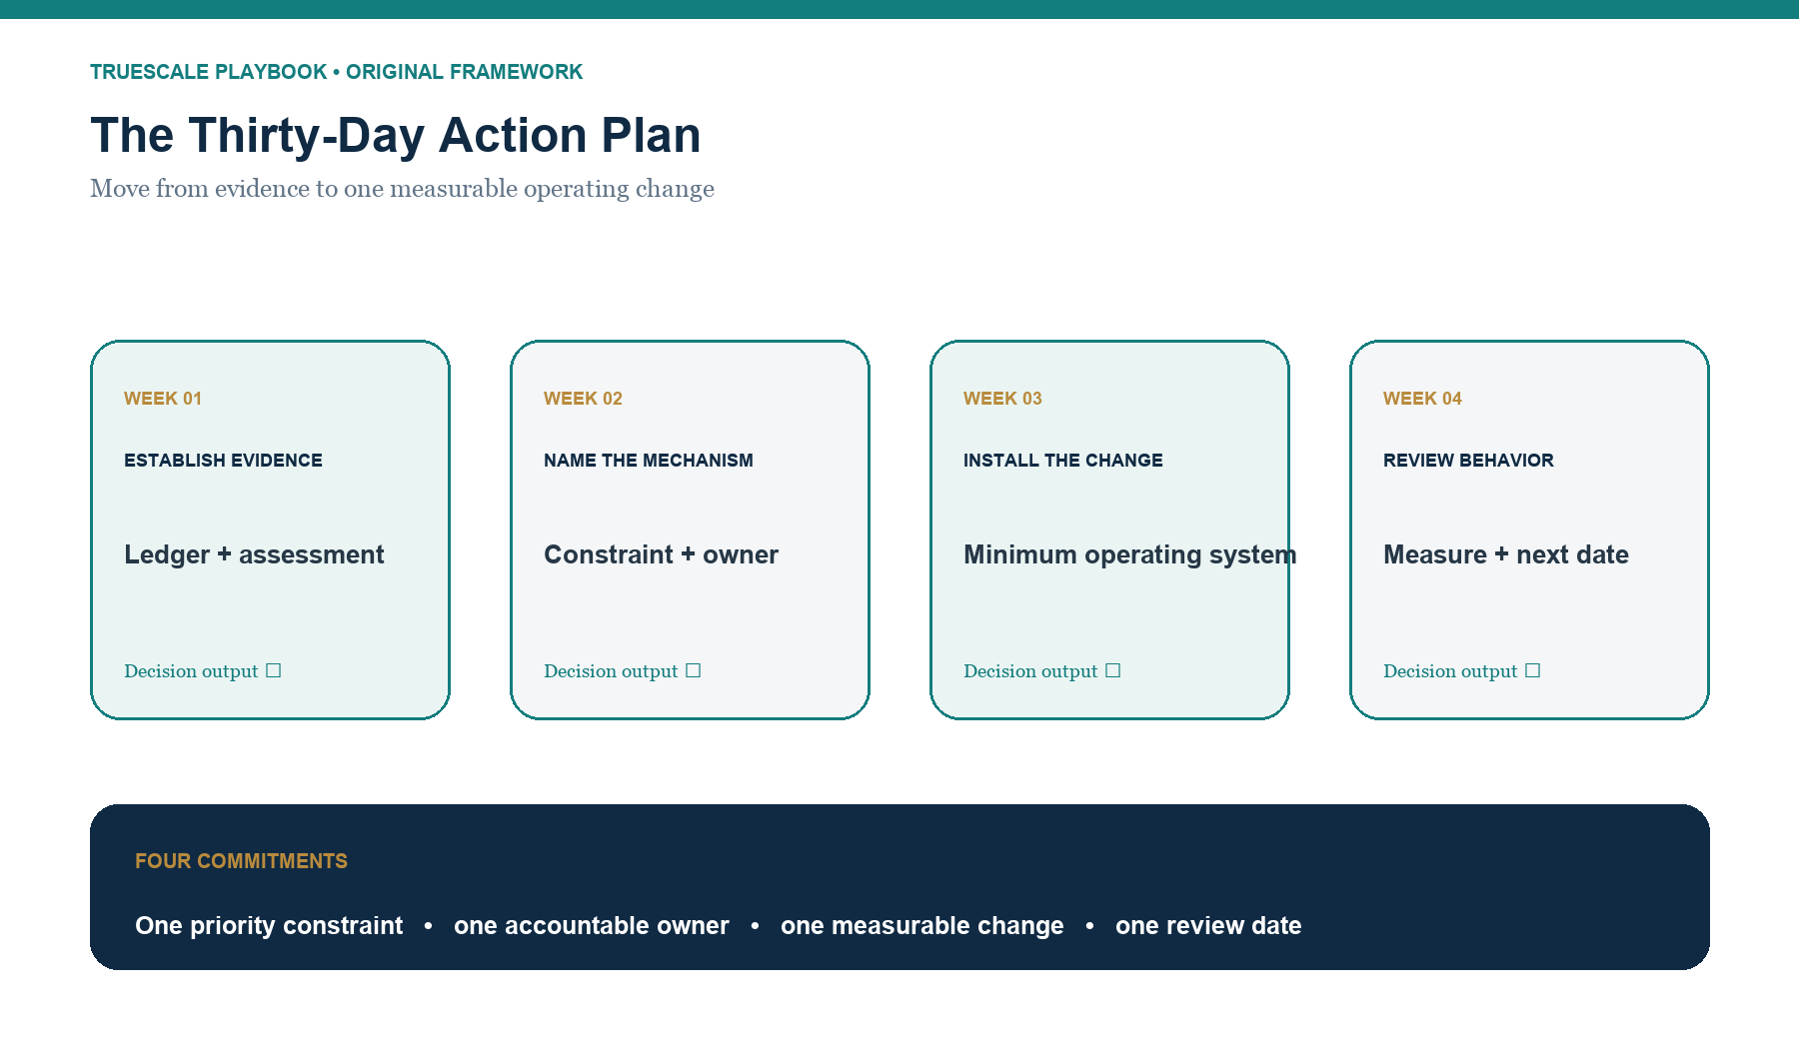
EXECUTIVE TOOL
Thirty-Day Action Plan
Commitment | Executive entry
One priority constraint
One accountable owner
One measurable operating change
One review date
EXECUTIVE TOOL
Thirty-Day Work Plan
Week | Decision and output
Week 1 - Establish evidence | Use the Operational Debt Ledger and Assessment Profile; select one evidenced constraint.
Week 2 - Make the mechanism visible | Trace ownership, handoffs, measures, exceptions, overlap, and financial treatment.
Week 3 - Install the minimum change | Clarify the owner, authority boundary, measure, response, and review rhythm.
Week 4 - Review behavior | Compare current evidence with the baseline; keep, revise, or stop the intervention; set the next date.
WORKED HYPOTHETICAL
Completed Hypothetical Thirty-Day Plan
Commitment | Completed teaching example
Constraint | Routine customer-credit decisions wait for senior approval.
Owner | Hypothetical COO.
Measurable change | Raise manager-level decisions to at least 80% while tracking decision time and harmful exceptions.
Review date | Thirty days after launch.
Method connection | Assess the decision queue; stabilize the approval boundary; scale the proven rule; accelerate only if the process and data are ready.

